GRAPHICAL USER INTERFACE(GUI)

INTRODUCTION TO GRAPHICAL USER INTERFACE(GUI)

Python offers multiple options for developing GUI(graphical user interface).out of the GUI methods,tkinter is most commonly used method.it is a standard python interface to the Tk GUI toolkit shipped with python.Python with tkinter outputs the fastest and and easiest way to create the GUI applications.Here we are going to learn how to create GUI apps in python using tkinter module .And also learn about all the elements needed to develop GUI apps in python. Tkinter is an inbuilt Python module used to create simple GUI apps.It is the most commonly used module for GUI apps in the python.

* How to create a file in excel using tkinter:

Book.save() is the command used to create a excel file.The output is new excel file is created in excel and it will display on the project explorer window.

Example:

from openpyxl import Workbook

Book =Workbook()

sheet= Book.active

**Book.save('report.xlsx')**

Output:

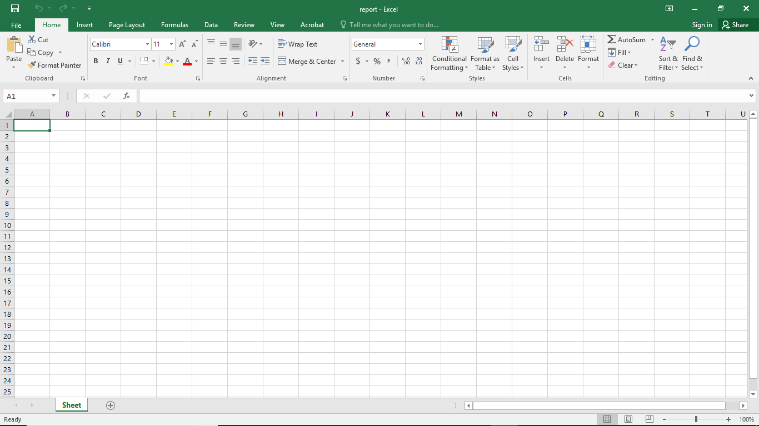

* To write on excel sheet :

sheet.append() is the command used to print the values or string on excel sheet.

Example:

from openpyxl import Workbook

Book =Workbook()

sheet= Book.active

**sheet.append(['hello'])**

Book.save('nandini.xlsx')

Output:

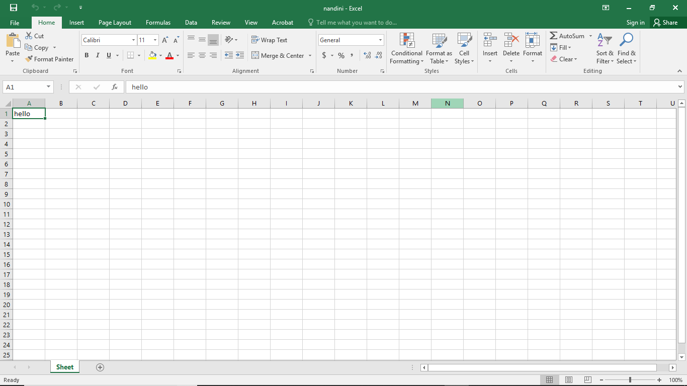

* How to read from excel sheet:

Book =load_workbook() is the command used to read the content from excel sheet.

a1=sheet['A1'] is the command used to take the values from excel file.

A1 is the address location of the value in the excel file.

print(a1.value) is the command used to print the value in console window.

output is,the value is print on the console window which is already stored in the excel file after run the programm.

Example:

from openpyxl import load_workbook

**Book =load_workbook('nandini.xlsx')**

sheet= Book.active

**a1=sheet['A1']**

**print(a1.value)**

Output:

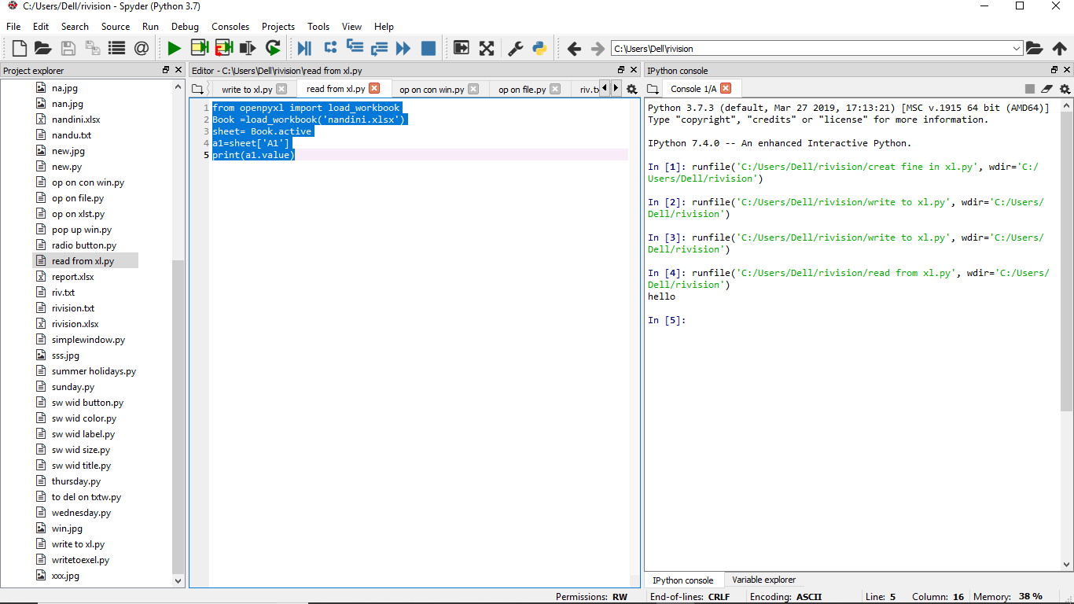

* To delete the already created excel file:

os.remove is the command used to delete a exel file in the project window.The excel file will be deleted which is in the stored in the project explorer window.

Example:

import os

from openpyxl import load_workbook

Book=load_workbook('nandini.xlsx')

sheet=Book.active

**os.remove('nandini.xlsx')**

* To creat a simple window:

window.geometry() is a command used to give size of the simple window.

window.configure() is a command used to give the background color for the simple window.

window.title() is a command used to give the title for the simple window.

from tkinter import * is a library function.

window.mainloop() is end of the loop.

Example:

**from tkinter import \***

window =Tk()

**window.geometry('1400x800')**

**window.configure(bg="pink")**

**window.title('nandini')**

**window.mainloop()**

Output:

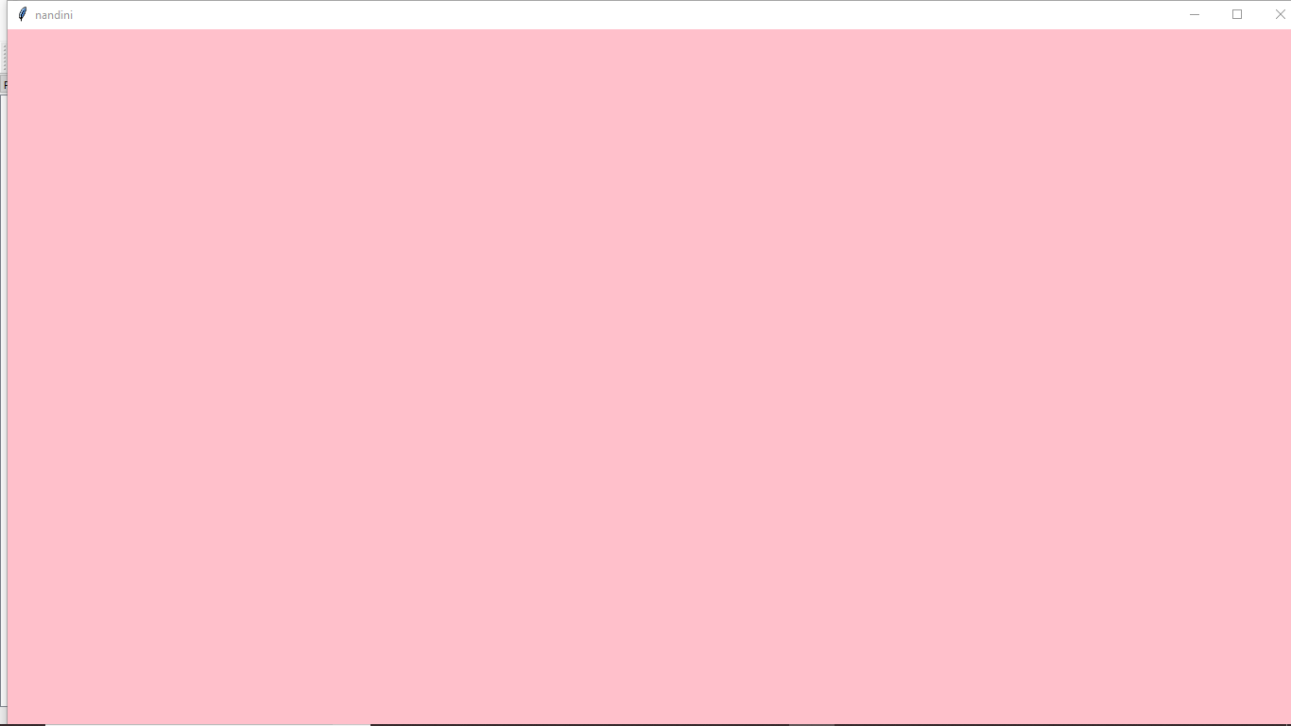

* To create a label in the simple window:

lb=Label() is the command used to give label in the window and lb is a user identifier,here we can give the font,background and foreground color,width and height of the label.and in the word Label L should be capital.

lb.pack is the command,it exactly place the label in the middle of the window.

lb.place is the command used to place the label where we want using x and y.

Example:

tkinter import *

window =Tk()

window.geometry('1400x800')

window.title('nandini')

**lb=Label(window,text='welcome',bg='blue',fg='yellow',font='20')**

**lb.pack()**

lb1=Label(window,text='name',bg='pink',fg='black')

**lb1.place(x=40,y=50)**

window.mainloop()

output:

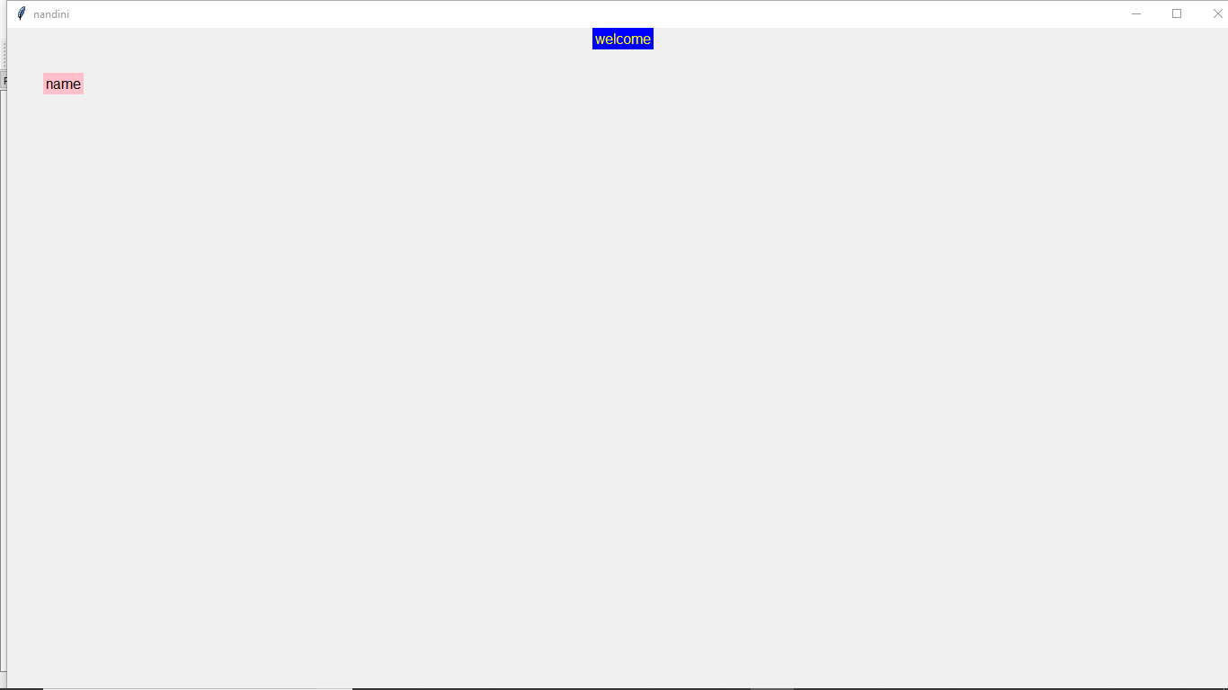

* To creat a text field in the window:

Text.Entry(window) is the command used to creat the text field,can write in the text field.

Example:

from tkinter import *window =Tk()

window.geometry('1400x800')

window.configure(bg=’blue’)

window.title('nandini')

lb=Label(window,text='welcome',bg='blue',fg='yellow',font=60)

lb.pack()

lb=Label(window,text='name',bg='pink',fg='black',font=60)

lb.place(x=40,y=50)

**text=Entry(window)**

**text.place(x=100,y=50)**

window.mainloop()

Output:

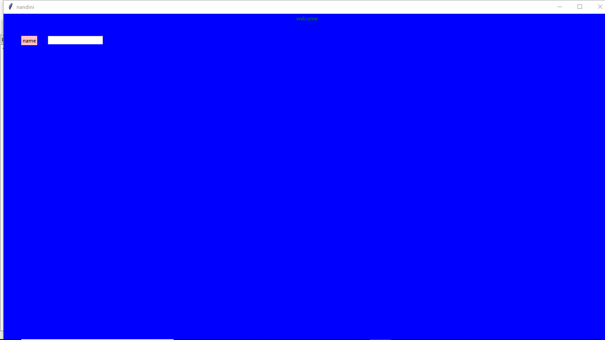

* To create a button in the window:

Bu=Button() is the command used to creat a button,we can clilck on that button.And here I am using submit as a button.bu is user identifier and in Button the B should be capital.

Example :

from tkinter import *

window =Tk()

window.geometry('1400x800')

window.configure(bg='pink')

**bu=Button(window,text='submit',bg='blue',width=40,height=5,font=40)**

**bu.place(x=100,y=200)**

window.mainloop()

output:

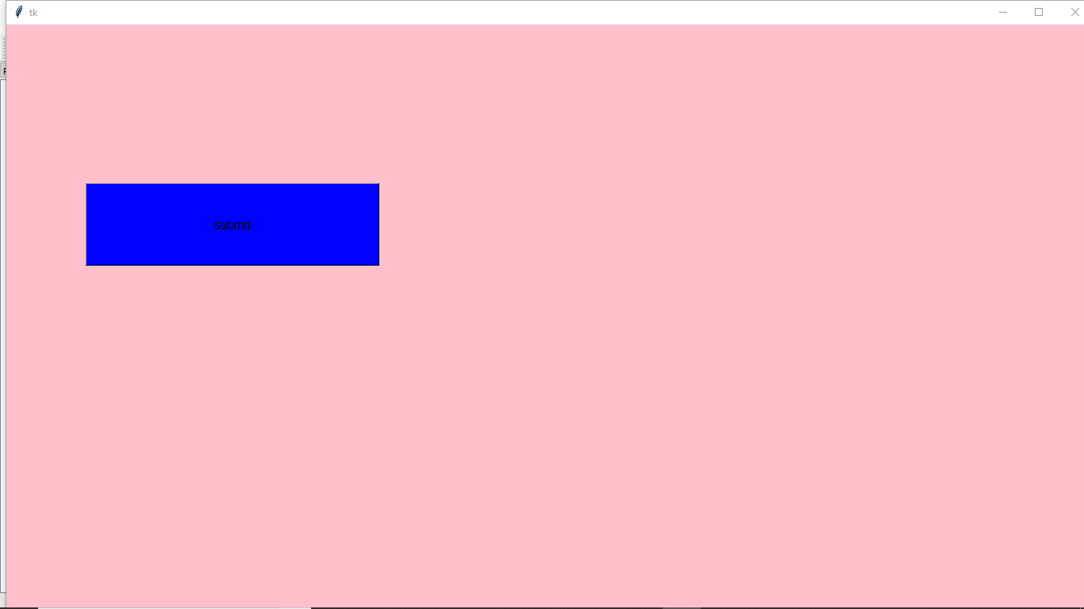

* To get the output on console window:

a=text.get() is the command used get the output value on console window.for example type your name in text field and click on submit.then your name is print on the console window.And it should be define within a function.

Example:

from tkinter import *

window =Tk()

window.geometry('1400x600')

window.configure(bg='pink')

lb=Label(window,text='name',bg='blue',fg='white')

lb.place(x=100,y=200)

text=Entry(window)

text.place(x=200,y=200)

**def fun():**

**a=text.get()**

**print(a)**

lb=Button(window,text='submit',bg='blue',fg='white',width=40,height=5,command=fun)

lb.place(x=200,y=350)

window.mainloop()

output:

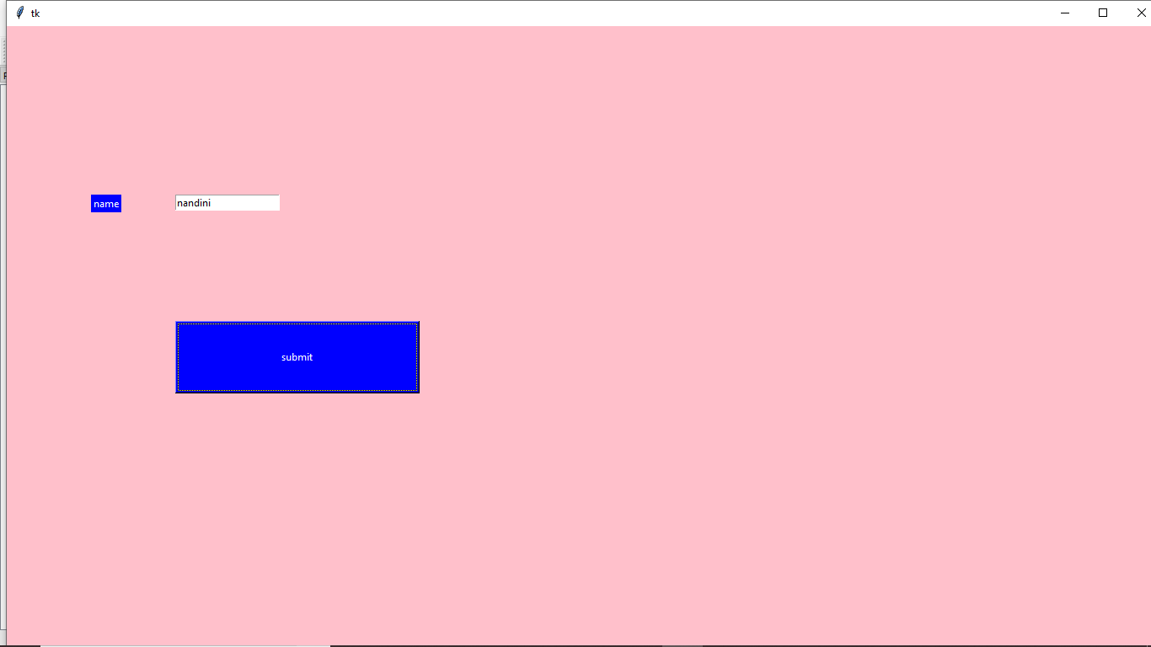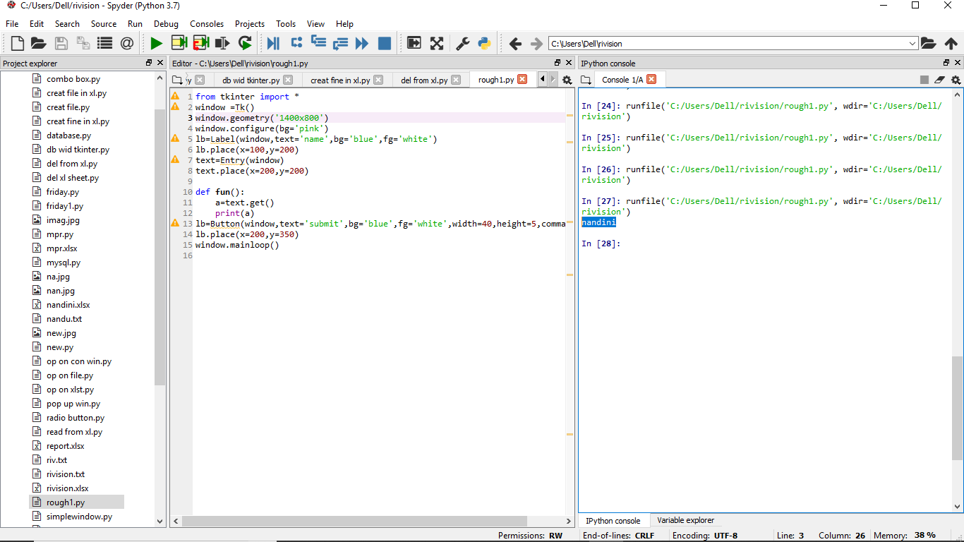

* To delete a value in the text field:

text.delete(0,END) is the command used to delete the values in the text field after clicking submit button.

Example:

from tkinter import *

window =Tk()

window.geometry('1400x800')

window.configure(bg='pink')

lb=Label(window,text='name',bg='blue',fg='white')

lb.place(x=100,y=200)

text=Entry(window)

text.place(x=200,y=200)

def fun():

a=text.get()

print(a)

**text.delete(0,END)**

lb=Button(window,text='submit',bg='blue',fg='white',width=40,height=5,command=fun)

lb.place(x=200,y=350)

window.mainloop()

* To creat a pop up window:

messagebox.showinfo() is the command used to get the pop up window after click on the button.

error is the message display on the pop up window.

Example:

from tkinter import *

from tkinter import messagebox

window =Tk()

window.geometry('1400x800')

window.configure(bg='pink')

**def fun():**

**print('error')**

**messagebox.showinfo('title','error')**

lb=Button(window,text='submit',bg='blue',fg='white',command=fun)

lb.place(x=100,y=200)

window.mainloop()

output:

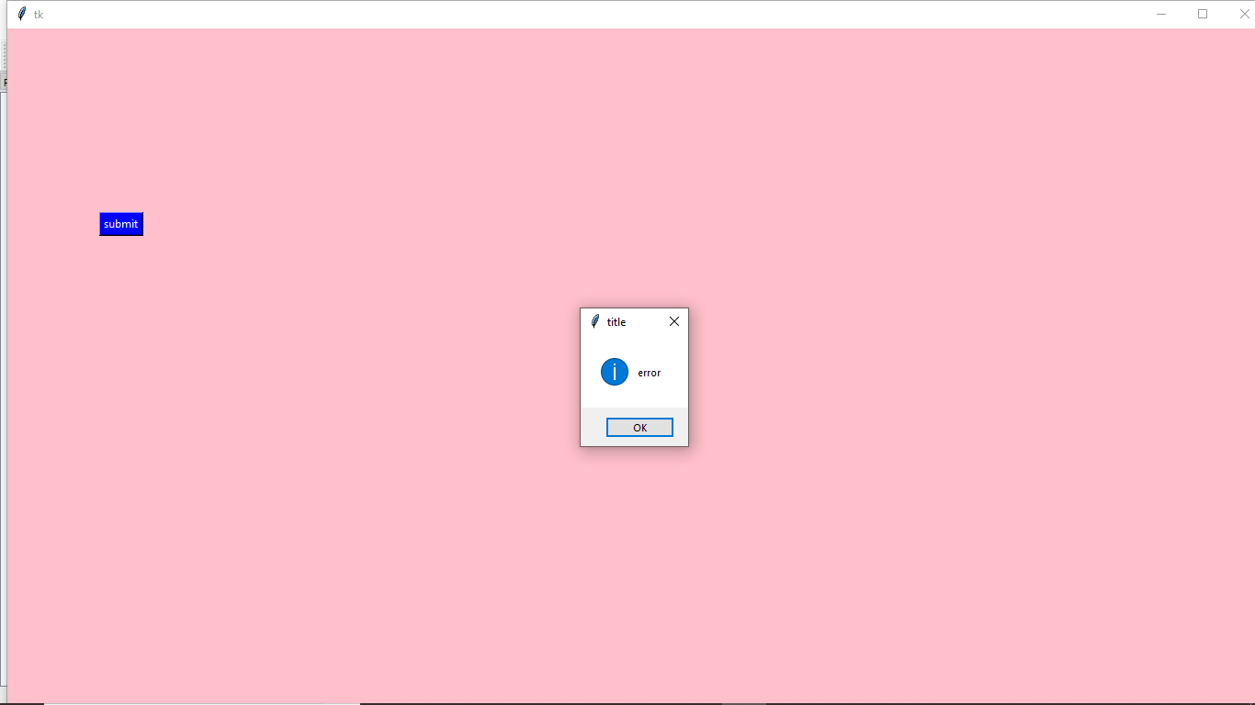

* To create a radiobuttons in the window:

from tkinter.ttk import * is a library function used for radio buttons.

var=StringVar() ,here we are using a string as male and female,so we have to use string,can also use int.

rad=Radiobutton() is the command used to create the radio buttons.

Example:

**from tkinter.ttk import \***

from tkinter import *

window =Tk()

window.geometry('1400x800')

window.configure(bg='pink')

**var=StringVar()**

**rad1=Radiobutton (window,text="male",value="male",variable=var,font=40)**

rad1.place(x=100,y=30)

rad2=Radiobutton(window,text="female",value="female",variable=var,font=40)

rad2.place(x=100,y=80)

window.mainloop()

Output:

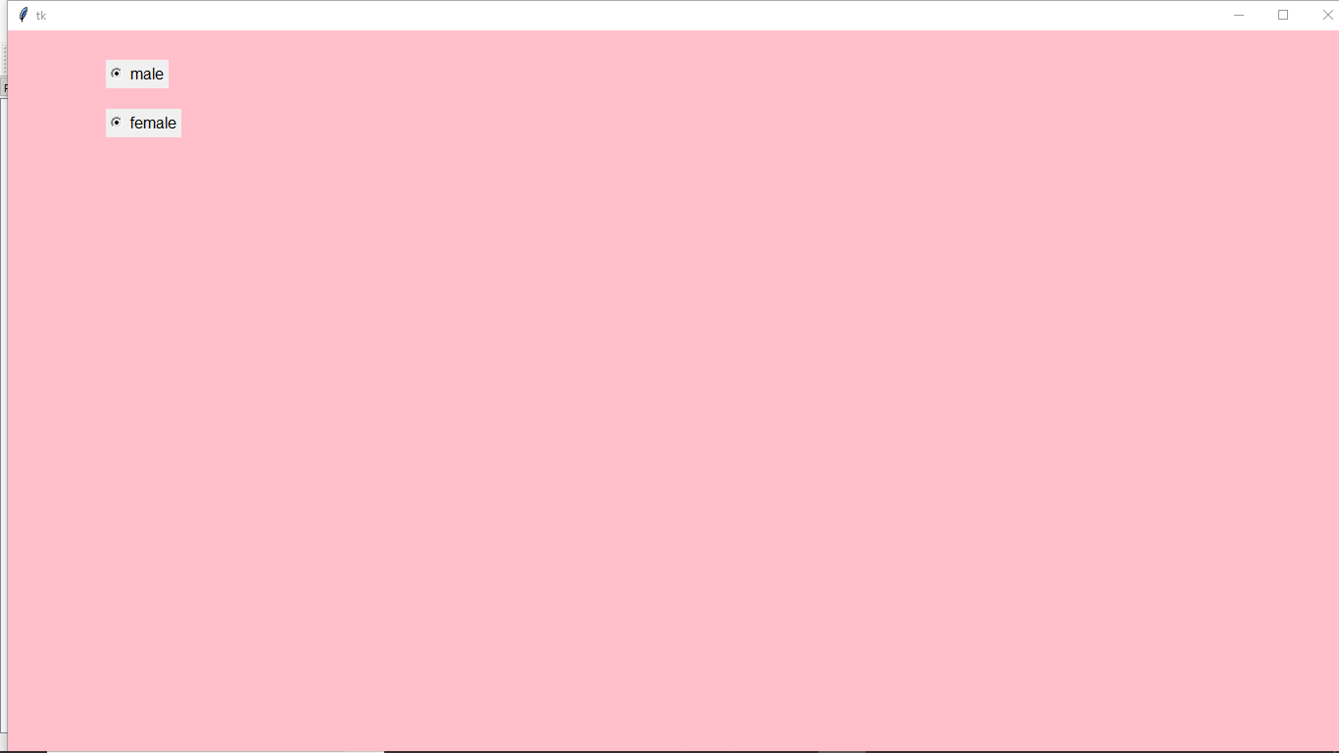

* To create a combo box in the window:

from tkinter.ttk import* is a library function used for combo box.

combo=Combobox() is the command used to creat a combo box inside the window.

combo[‘values’]=() is the command used to give the values we want.

Example:

from tkinter import *

**from tkinter.ttk import \***

window=Tk()

window.geometry('1400x800')

**combo=Combobox(window)**

**combo['values']=(1,2,3,4,5)**

combo.place(x=100,y=150)

**combo.bind("<<ComboboxSelected>>")**

window.mainloop()

Output:

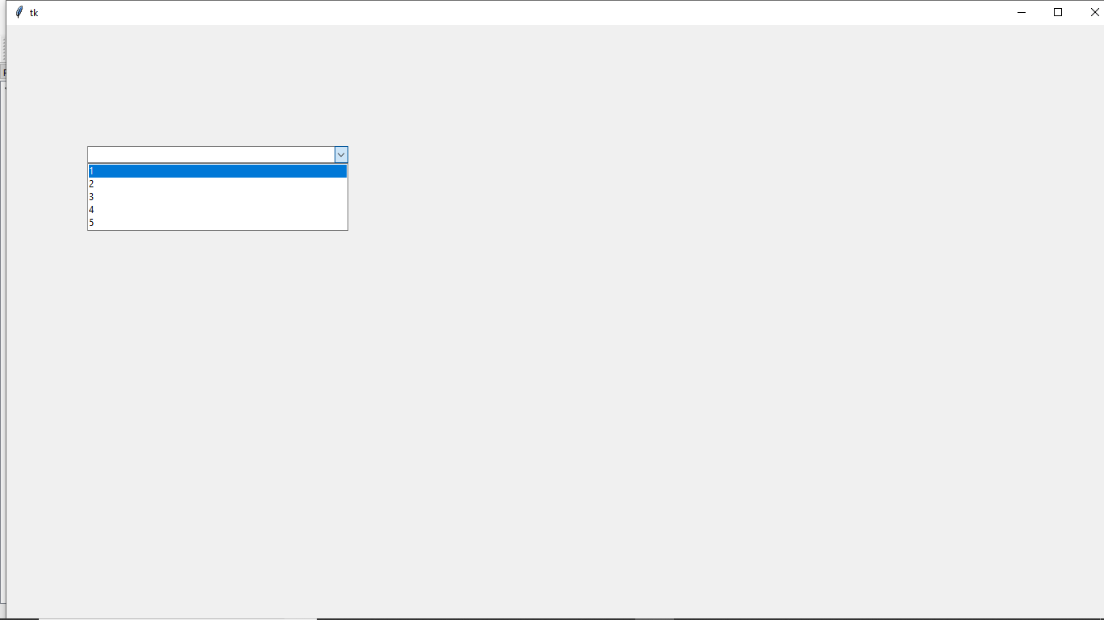

* To print background image to the window:

from PIL import ImageTk,Image” , “from tkinter import filedialog” ,” import os are the library functions used to create image in the window.

img=ImageTk.PhotoImage(Image.open("imag.jpg")) is the command used to select the image which is already stored in the project explorer window.

lb=Label(window,image=img) is the command used to print the image in window.

Example:

from tkinter import *

**from PIL import ImageTk,Image**

**from tkinter import filedialog**

**import os**

window =Tk()

window.geometry('1400x800')

window.configure(bg='pink')

**img=ImageTk.PhotoImage(Image.open("imag.jpg"))**

**lb=Label(window,image=img)**

lb.pack()

window.mainloop()

Output:

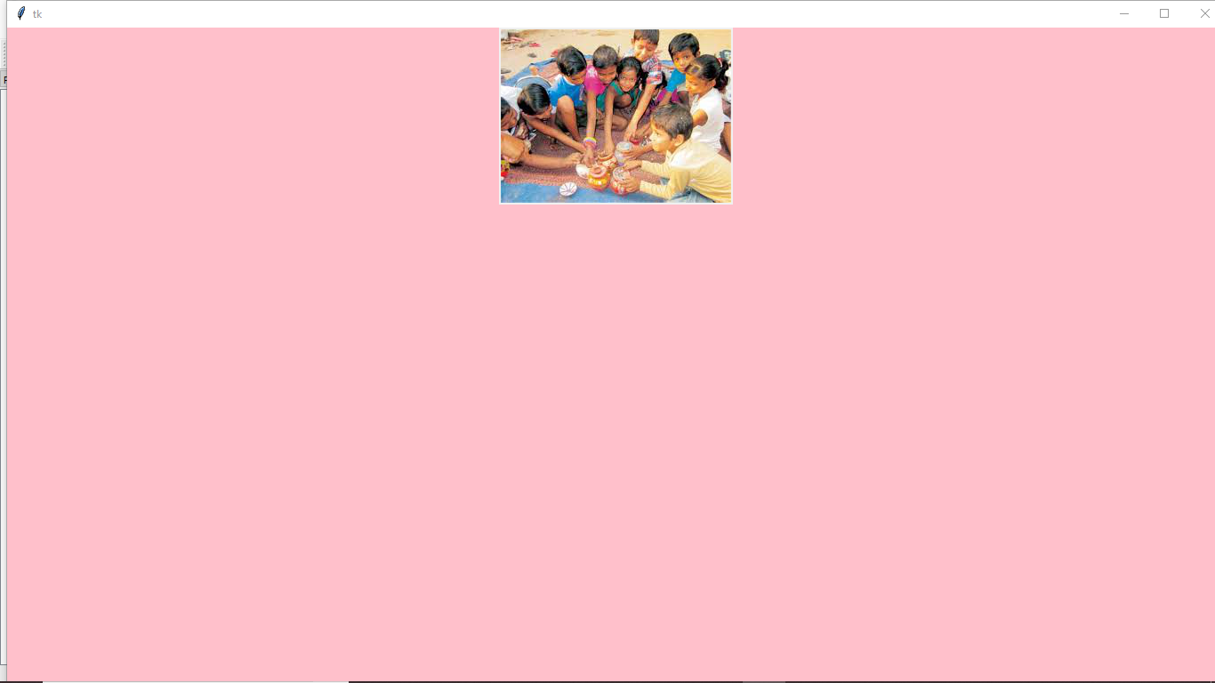

* Frames using tkinter in simple window:

Fr=Frame() is the command used to creat frames.we can create one or more frames inside the simple window.here as shown in the example in the simple window we are created three frames.in first frame created one submit button, if I click that button the second frame will open and it contain two buttons such as next and back.if I click back button it will come to first frame,if I click a next button it will go for next frame.

Example:

from tkinter import *

window =Tk()

window.geometry('1400x800')

window.title('nandini')

**fr=Frame(window,bg="blue",width=500,height=500)**

fr.place(x=1,y=1)

bt=Button(fr,text="submit",command=fun)

bt.place(x=200,y=250)

def fun():

f1=Frame(window,bg="pink",width=500,height=500)

f1.place(x=1,y=1)

id1=Button(f1,text="next",command=fun1)

id1.place(x=200,y=300)

id2=Button(f1,text="back",command=lambda:fun2(fr))

id2.place(x=300,y=300)

def fun1():

f2=Frame(window,bg="yellow",width=500,height=500)

f2.place(x=1,y=1)

bt1=Button(f2,text="submit")

bt1.place(x=200,y=200)

def fun2(frame):

frame.tkraise()

window.mainloop()

Output:

